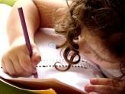  Writing  In Talk4Writing this half-term we will be writing our own losing tale stories based on our model text, The Game. This story follows a similar structure to the classic movie Jumanji.  We will focus on adverbial phrases, use of speech and figurative language.  We will then be studying the non-fiction text, Nightmare Man. In this unit, we be using rhetorical questions, working on paragraphing and developing our sentence structures to engage our reader. | 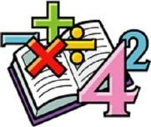  Maths  In Maths this half term we will be working on methods of multiplication and division. Later on this half term, we will be learning to multiply fractions and find fractions of an amount.  We will continue to improve our recall of times tables facts and our mental arithmetic skills. |  | Science  In Science, our topic this half term in forces. We will be learning about gravity, friction and the effects of air and water resistance.  We will be conducting some experiments using different lines of Science enquiry. We aim to develop our ability to plan and conduct experiments whilst using scientific equipment to help us. | Computing  In computing this half-term we will be looking at the Programming Music. We will be creating a program that plays themed music, In addition, we will plan and program soundtracks for a specific purpose.
Humanities  We will be heading to the Antarctic to discover the Heroic Age of Antarctic Exploration!  Our focus will be on the time line of events around the discovery, expeditions and the Antarctic treaty.  We will research and compare the journeys of different explorers such as Scott, Shackleton and Amundsen. | 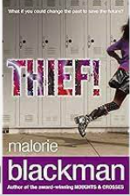  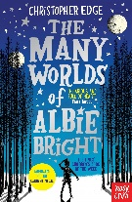  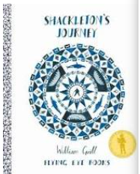  Our class books  Thief by Malorie Blackman  Shackleton’s Journey – William Grill  Poetry – The work of Benjamin Zephaniah |  |  | PSHE/RSE  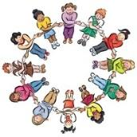  In PSHE this half term we will be thinking about citizenship. We will begin to understand what happens when the law is broken.  The children will explore the links between rights and responsibilities with links to helping the environment. We will look at the role of pressure groups and begin to have some understanding of how parliament works.
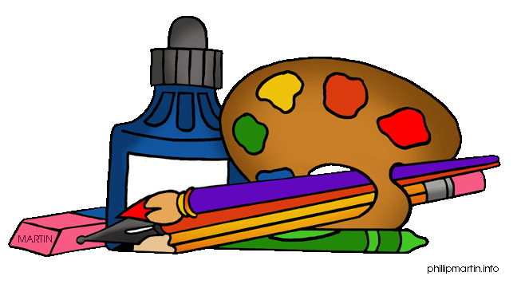  Art and DT  Our Art topic this half term is all about fashion design. We will be exploring the work of contemporary fashion designers such as; Alice Fox, Rahul Mishra and Pyer Moss.  We will work with a brief to create a design. Our designs will be based around an Antarctic Exploration to link with our exciting History topic!  The final piece will be created in 3D form using a mannequin. | PE  In PE this half-term we will be developing our basketball skills. Children will learn to control and pass the ball using good techniques, improve their aim and move past defenders.  We will also be continuing swimming implementing our skills and developing confidence in the pool. | Music  In music this half-term, we will be studying music from South and West Africa. Children will learn to sing a traditional African song and play tuned percussion to accompany. We will be playing call and response rhythms using percussion. |  | RE  In RE this half-term we will be looking at ‘If God is everywhere, why do we go to places of worship?’.  We will be learning about different places of worship for Christians, Hindus and Jewish people. Children will consider what places of worship mean to believers.

